[ MIDWAY REPORT ]

Holiday vs. Post-Holiday Spending
A Statistical Analysis of Credit Card Transactions
David Nathaniel P. Riego
Statistical Computing
April 2026

1. Introduction and Background
Consumer spending patterns are widely assumed to shift during the holiday season. December is characterized by gift-giving, festive celebrations, and increased retail activity, while January is typically associated with post-holiday budget restraint. This study examines whether a statistically significant difference exists in mean credit card transaction amounts between December 2019 and January 2020.

The central research question is: Do mean credit card transaction amounts differ significantly between December 2019 and January 2020?

For the hypotheses let:
- μ_{D}​ = mean transaction amount in December
- μ_{J}​ = mean transaction amount in January

The null hypothesis states that the population mean transaction amounts are equal across the two months (H₀​: μ_{D} ​= μ_{J}). The alternative hypothesis states that they differ (H_{a}: μ_{D} ​≠ μ_{J​}). A two-sided test is used since the goal is to detect any difference, not just increase or decrease.

The dataset used is a simulated credit card transaction record containing approximately one million entries from the year 2019 through early 2020 (Choksi, 2020). After cleaning and filtering, the final analytical sample consisted of 192,327 legitimate transactions: 140,468 from December 2019 and 51,859 from January 2020. Fraudulent transactions were excluded to focus the analysis on genuine consumer behavior. {{ Comment: Mention that this was possible because the dataset already has a column for "is fraudulent" and it's marked with 01. All we did was remove every row that had "is fraudulent" equals one }}
2. Data Description
2.1 Source and Preprocessing
The dataset was sourced from Kaggle (Choksi, 2020) and consists of simulated credit card transaction records. The raw file contained 1,048,575 rows and 24 columns, including cardholder demographics, merchant information, geographic coordinates, transaction amounts, fraud labels, and timestamps. Dates were stored as Excel serial numbers and required conversion to standard datetime format before any filtering could be applied.

Preprocessing was performed in Python using the pandas library (McKinney, 2010).{{Comment: Let's clarify that when we say that it's McKinney, we're just citing that the Pandas library is from McKinney. The pre-processing was not done from McKinney. It wasn't done by McKinney. It's just that the Pandas library is from McKinney.

Let's try to rephrase this so that it's more understood that pre-processing was performed in Python from McKinney but the pre-processing was just performed via Python and the steps are below}}
Steps included: (1) converting Excel serial dates to datetime objects, (2) filtering rows to retain only December 2019 and January 2020 records, (3) removing fraudulent transactions (is_fraud = 1), (4) dropping invalid amounts (zero or negative values as to which none were found), and (5) checking for missing values (no nulls found as well). The cleaned dataset was exported as a CSV file for analysis in R.

2.2 Variables
Table 1 describes the four variables retained after preprocessing. The primary outcome variable is amt (in USD). The grouping variable is period (December or January).

Table 1
Variable descriptions for the cleaned credit card transaction dataset.
{{Comment: Should be “Variable Descriptions for the Cleaned Credit Card Transaction Dataset” with no period}}
Variable | Type | Description
transaction_date | Date | Date and time of the transaction
period | Categorical (Factor) | Month group: 'December' (2019) or 'January' (2020)
amt | Numerical (Continuous) | Transaction amount in US dollars (USD)
category | Categorical | Merchant category (e.g., grocery_pos, entertainment)
Note. 192,327 transactions: 140,468 (December) and 51,859 (January).
{{Comment: A note is not required if a text or a paragraph already mentions what the note is saying. In this case 192,327 transactions, and in the transactions of that December and January, were already mentioned so in that case we don't need to have a note for it }}

3. Exploratory Data Analysis
3.1 Descriptive Statistics
Table 2 summarizes transaction amounts for each period. Both months are strongly right-skewed, shown by means exceeding medians (e.g., December: $68.22 vs. $47.16). Average transaction amounts are very similar between December ($68.22) and January ($67.11), and the difference is small relative to the large variability (SD: $175.15 vs. $122.82). December shows more variability because of the high value of transactions (max: $28,948.90 vs. $6,880.74). High skewness in both groups confirms that the data are non-normal {{Comment: My professor told me that I can just invoke the central limit theorem when dealing with non-normal data because we have a lot of data points}} , supporting the use of non-parametric or transformed methods.

Table 2
Descriptive statistics of transaction amounts (USD) by period.
Statistic | December 2019 | January 2020
n (transactions) | 140468 | 51859
Mean (USD) | 68.22 | 67.11
Median (USD) | 47.16 | 47.38
Std. Deviation | 175.15 | 122.82
Minimum | 1 | 1
Maximum | 28948.9 | 6880.74
Q1 (25th pct.) | 9.53 | 9.57
Q3 (75th pct.) | 82.43 | 82.8
IQR | 72.9 | 73.23
Skewness | 70.98 | 15.92

3.2 Distribution Visualizations
Figure 1 shows side-by-side histograms of log10-transformed transaction amounts for each period. The log transformation was applied to reduce the impact of extreme outliers and improve visual clarity. Both distributions appear bimodal on the log scale suggesting two distinct clusters of transaction sizes in the data. Importantly, the shape of the distribution is nearly identical between the two months.

Figure 1
Distribution of Transaction Amounts by Period {{Comment: Distribution of Transformed Transaction Amounts by Period}}
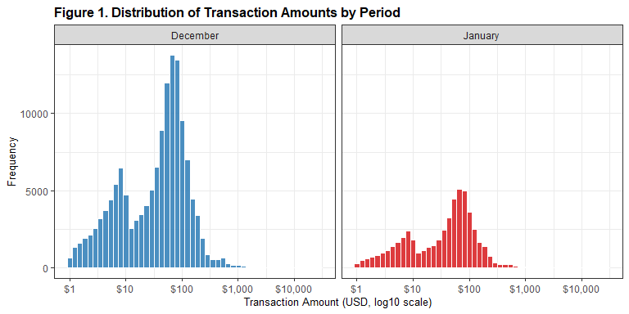

Figure 2 displays side-by-side boxplots of raw transaction amounts. Both groups share a similar median and interquartile range, with a large number of outliers in the upper tail. The near-identical boxplots visually confirm the lack of a meaningful difference between groups.

Figure 2
Transaction Amount Distribution by Period {{Comment: Boxplot of RAW needs to be presented before the histogram of RAW and before the transformed. Boxplot first: RAW and transformed, and then histogram: RAW and transformed }}
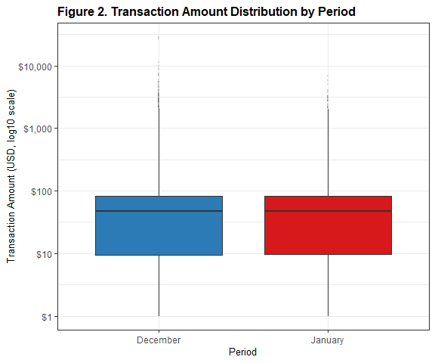

3.3 Transaction Category Distribution
Table 3 shows the proportion of transactions by category for each period. Category proportions are nearly identical between December and January, suggesting that spending behavior is consistent across the two months.

Table 3
Transaction counts and percentages by category and period.
Category | n (Dec) | % (Dec) | n (Jan) | % (Jan)
gas_transport | 14270 | 10.2 | 5237 | 10.1
home | 13458 | 9.6 | 4985 | 9.6
grocery_pos | 13220 | 9.4 | 4857 | 9.4
shopping_pos | 12708 | 9 | 4645 | 9
kids_pets | 12139 | 8.6 | 4504 | 8.7
shopping_net | 10537 | 7.5 | 3901 | 7.5
entertainment | 10303 | 7.3 | 3815 | 7.4
food_dining | 9846 | 7 | 3643 | 7
personal_care | 9820 | 7 | 3639 | 7
health_fitness | 9267 | 6.6 | 3516 | 6.8
misc_pos | 8738 | 6.2 | 3216 | 6.2
misc_net | 6710 | 4.8 | 2478 | 4.8
grocery_net | 4985 | 3.5 | 1817 | 3.5
travel | 4467 | 3.2 | 1606 | 3.1

Figure 3 presents a grouped bar chart of transaction counts by category and period. The chart confirms that the category mix is proportionally equivalent across the two months.

{{Comment: Since table 3 and figure 3 would represent the same description, they can be stated together like table 3 and figure 3 }}

Figure 3
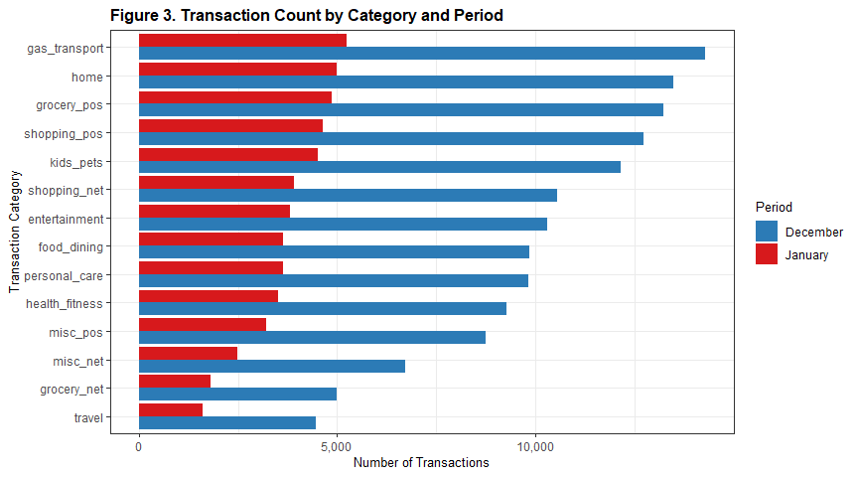
Transaction Count by Category and Period
Figure 4 displays overlapping density curves of log10-transformed transaction amounts for December and January. The two distributions are nearly indistinguishable, with the December and January curves tracing almost the same path across the entire range. The near-perfect overlap between the two density curves provides strong visual confirmation that the distribution of transaction amounts did not shift meaningfully between December 2019 and January 2020.

Figure 4
Density of Transaction Amounts by Period
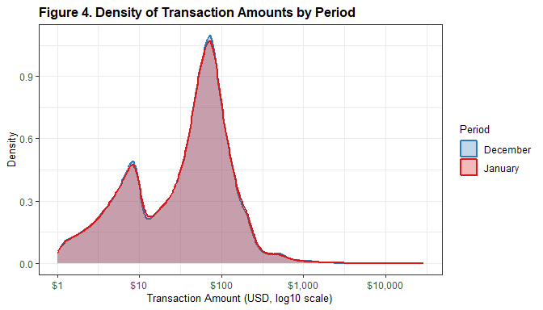
4. Hypothesis Testing
4.1 Hypotheses
Due to non-normality identified in the assumption checks (Section 4.2), the original mean-based framework was not appropriate. Parametric tests comparing means rely on distributional assumptions that are clearly violated in this dataset, particularly due to strong right skew and extreme outliers. As a result, the analysis was reframed in terms of median transaction amounts, and a non-parametric test was selected as the primary method.

Accordingly, the research question is reframed as: Is there a difference in the distribution of transaction amounts between December 2019 and January 2020, particularly in terms of central tendency (location)? {{Comment: So apparently my professor did not like this and they said that it's not part of our lesson. We need to keep the questions within what can be answered by what we studied in class. Essentially her advice to me is to keep my original hypothesis and just invoke the central limit theorem.

Our future test might be affected by this so we have to redo what happens after this paper. This is the main biggest fix. We need to invoke the central limit theorem and keep our hypothesis. This is the same as we had before }}

Let X_{D} and X_{J} denote the distributions of transaction amounts in December and January, respectively. Given the similar distribution shapes observed in the EDA, differences in distribution can be interpreted as differences in central tendency (particularly the median).

The formal hypotheses are stated as follows:
- H₀ ​: The distributions of transaction amounts are the same (X_{D} ​= X_{J})
- Ha : The distributions differ (X_{D} ​≠ X_{J})

A two-tailed test is used, as the objective is to detect any difference rather than a specific direction. The significance level is set at α=0.05.

4.2 Assumption Checks
Before selecting a hypothesis test, two assumptions were examined: normality of the outcome variable within each group, and equality of variances between groups.

Normality was assessed using both quantile-quantile (Q-Q) plots and the Shapiro-Wilk test. Figure 5 shows Q-Q plots for raw transaction amounts in each period. Both plots show deviation from the reference line, particularly in the upper tail, indicating strong right skew and departure from normality in both groups.

Figure 5
Normal Q-Q Plots by Period
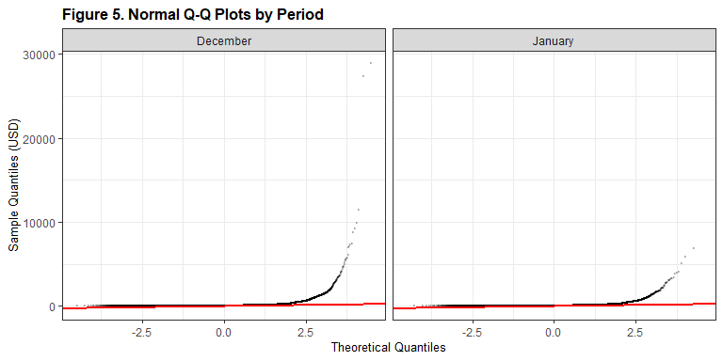

To formally quantify this, the Shapiro-Wilk test was applied to a random sample of 5,000 observations per group, as the test requires n ≤ 5,000. Results are presented in Table 4.

Table 4
Shapiro-Wilk Normality Test Results by Period (n = 5,000 per group)
Group | W | p-value | Conclusion
December | 0.4136 | <.001 | Non-normal
January | 0.5689 | <.001 | Non-normal
{{Comment: We need to clarify whether we did the test on different groups or on just one sample and if it's different groups, how did we correct for the table? The professor is very confused, like this is on different groups or is this on just one sample }}
The following R code was used to produce these results:
set.seed(42)

dec_sample <- sample(dec_amt, size = min(5000, length(dec_amt)))
jan_sample <- sample(jan_amt, size = min(5000, length(jan_amt)))

shapiro_dec <- shapiro.test(dec_sample)
shapiro_jan <- shapiro.test(jan_sample)

W values {{Comment: One of the comments as well is that we should conclude based on p-value not w. We can include what w will tell us but make sure to include reasoning also using the p-values}} of 0.41 and 0.57 represent non-normality. Values this low indicate that the data departs substantially from a normal distribution. As a result, a direct t-test on raw transaction amounts is not appropriate, and a non-parametric or transformation-based approach is required. {{Comment: Again for this one we can just invoke CLT and make our entire project simpler. We didn't need to run so since we didn't invoke CLT, we ran twice the number of tests that we should have done. We can keep our original hypothesis and just invoke CLT }}

Levene's test was used to assess whether the two groups have equal variances, as it is robust to non-normality. Results are presented in Table 5.

Table 5
Levene's Test for Equality of Variances
Test | F-statistic | p-value | Conclusion
Levene's Test | 2.2024 | 0.138 | Equal variances
{{Comment: Ideally tables should have more than one row so if it doesn't, it could just be mentioned in a paragraph }}

The following R code was used to produce these results:
levene_result <- leveneTest(amt ~ period, data = df)

cat("Levene's Test for Equality of Variances:\n")
cat("F-statistic:", round(levene_result$`F value`[1], 4), "\n")
cat("p-value:", format(levene_result$`Pr(>F)`[1], scientific = TRUE), "\n")

The result was F(1, 192325) = 2.20, p = .138, indicating no statistically significant difference in variance between December and January at the α = .05 level.

4.3 Primary Test: Mann-Whitney U {{Comment: So yeah this is the thing that wasn't really discussed in class. We're not allowed to use man with new you for this paper unfortunately. I think we don't really need it because we're going to invoke CLT on our original hypothesis. We wouldn't really need man with new you}}
Given the non-normality detected in Section 4.2, the Mann-Whitney U test (also known as the Wilcoxon rank-sum test) was selected as the primary hypothesis test. This non-parametric test compares the distribution of ranks between two groups and does not assume normality. The test was conducted in R using the wilcox.test() function. Results are presented in Table 6.

Table 6
Mann-Whitney U Test Results
W Statistic | p-value | 95% CI (Location Shift) | Hodges-Lehmann Estimator | Conclusion
3633428236 | 0.414 | [−0.36, 0.15] | −0.11 | Fail to reject H₀
Note. Two-sided test. A confidence interval containing zero is consistent with no significant location shift.

The following R code was used to produce these results:
wilcox.test(dec_amt, jan_amt,
alternative = "two.sided",
conf.int = TRUE,
conf.level = 0.95)

The test yielded W = 3,633,428,236, p = .414. The 95% confidence interval for the location shift (Hodges-Lehmann estimator) was [-0.36, 0.15], which includes zero. Because p > .05, we fail to reject the null hypothesis. Therefore, there is insufficient evidence to conclude that the distribution of transaction amounts differs between December 2019 and January 2020, and consequently no evidence of a difference in central tendency, particularly the median.

4.4 Secondary Test: Log-Transformed t-Test
As a robustness check, a two-sample Welch t-test was applied to log10-transformed transaction amounts. Before running the test, the log transformation was verified to substantially improve normality. Figure 6 shows Q-Q plots of the log-transformed amounts for each period, and Table 7 presents the corresponding Shapiro-Wilk results.

Figure 6
Q-Q Plots of Log10-Transformed Transaction Amounts
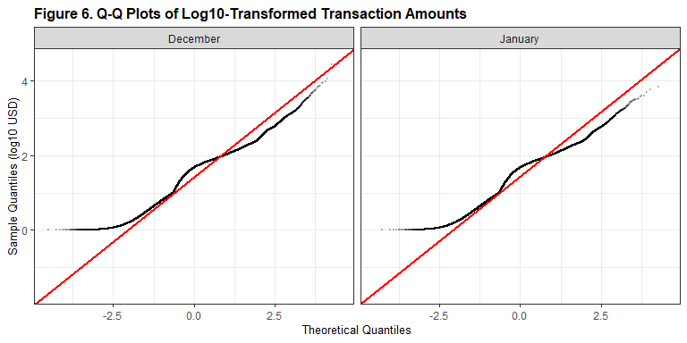

Table 7
Shapiro-Wilk Normality Test Results on Log-Transformed Transaction Amounts (n = 5,000 per group)
Group | W Statistic | p-value | Conclusion
December 2019 | 0.9503 | < .001 | Approximately normal
January 2020 | 0.9521 | < .001 | Approximately normal
Note. W values above 0.95 indicate a substantially improved fit to normality.
Compared to the raw data (W = 0.41 and W = 0.57), the log-transformed W values of 0.9503 and 0.9521 represent a dramatic improvement in normality, supporting the use of a t-test on the transformed scale. This secondary test allows comparison of geometric means and the results are presented in Table 8.

Table 8
Welch Two-Sample t-Test Results on Log10-Transformed Transaction Amounts
t-statistic | df | p-value | 95% CI (log scale) | Geometric Mean (Dec) | Geometric Mean (Jan) | Conclusion
−0.4756 | 192325 | 0.634 | [−0.0075, 0.0046] | 31.28 | 31.39 | Fail to reject H₀
Note. Geometric means were obtained by back-transforming log10 group means to USD. A confidence interval containing zero on the log scale indicates no significant difference in geometric means.

The following R code was used to produce these results:
dec_log <- log10(dec_amt)
jan_log <- log10(jan_amt)
t.test(dec_log, jan_log, var.equal = FALSE)

The log-transformed t-test yielded t = -0.4756, p = .634. The geometric means were nearly identical: $31.28 for December and $31.39 for January. The 95% confidence interval on the log scale [-0.0075, 0.0046] is extremely narrow, indicating that any true difference, if one exists, is practically negligible. This result is consistent with the Mann-Whitney U test.

4.5 Convergence of Results
Table 9 presents a convergence summary comparing the results of both tests across key output metrics.

Table 9
Summary of hypothesis test results.
Test | p-value | Decision | Conclusion
Primary: Mann-Whitney U | 0.41 | Fail to Reject H0 | No significant difference in distribution
Secondary: Log t-Test | 0.63 | Fail to Reject H0 | No significant difference in geometric means

Both tests converge on the same conclusion: fail to reject H0. The Mann-Whitney U test and the log-transformed t-test each produce p-values well above the 0.05 threshold, and both confidence intervals include zero. This convergence strengthens confidence in the finding.

5. Discussion
5.1 Interpretation of Findings
The analysis found no statistically significant difference in the distribution of transaction amounts between December 2019 and January 2020, p = .414 (Mann-Whitney U). This result is contrary to the initial expectation that holiday spending in December would produce higher transaction amounts than the post-holiday month of January. The Hodges-Lehmann location shift estimate of -0.11 suggests that December transactions were actually marginally lower than January, though this difference is neither statistically significant nor practically meaningful given the confidence interval of [-0.36, 0.15].

The EDA reinforced this finding. Category proportions were nearly identical between the two periods, with no category differing by more than 0.1 percentage points. The distribution plots showed near-perfect overlap between December and January. These patterns suggest that, in this dataset, spending behavior was uniform across the two months.
5.2 Limitations
The primary limitation of this study is that the dataset is synthetically generated to simulate realistic transactions (Choksi, 2020). Simulated data may not capture the seasonal variation present in real-world spending behavior, which likely explains the absence of the expected December effect. Findings from this analysis should therefore not be generalized to actual consumer spending patterns without validation against verified real-world transaction data.

References
Choksi, P. (2020). Credit card transactions fraud detection dataset [Data set]. Kaggle. https://www.kaggle.com/datasets/priyamchoksi/credit-card-transactions-dataset
Fox, J., & Weisberg, S. (2019). An R companion to applied regression (3rd ed.). Sage. [car package]
McKinney, W. (2010). Data structures for statistical computing in Python. Proceedings of the 9th Python in Science Conference, 51-56. [pandas library]
R Core Team. (2023). R: A language and environment for statistical computing. R Foundation for Statistical Computing. https://www.R-project.org/
Wickham, H. (2016). ggplot2: Elegant graphics for data analysis. Springer-Verlag.
Wickham, H., Averick, M., Bryan, J., Chang, W., McGowan, L. D., Francois, R., Grolemund, G., Hayes, A., Henry, L., Hester, J., Kuhn, M., Pedersen, T. L., Miller, E., Bache, S. M., Muller, K., Ooms, J., Robinson, D., Seidel, D. P., Spinu, V., ... Yutani, H. (2019). Welcome to the tidyverse. Journal of Open Source Software, 4(43), 1686. https://doi.org/10.21105/joss.01686
Xie, Y. (2023). knitr: A general-purpose package for dynamic report generation in R (R package version 1.42). https://yihui.org/knitr/
Zhu, H. (2021). kableExtra: Construct complex table with kable and pipe syntax (R package version 1.3.4). https://CRAN.R-project.org/package=kableExtra

